How to Play Recorded Music Over the Sound System

Minneapolis Friends Meeting
May 2014

If you want to play recorded music (or any recorded audio) over the sound system, you need to bring in the recording you want to play AND a device that can play it. The Meetinghouse does not have CD players, tape players, or any other playback equipment.
The device you bring in needs to have a 3.5 millimeter earphone jack. That's a small round opening that a 3.5mm male connector can be plugged into. On most current audio devices that have earphone jacks -smart phones, iPods, CD players, etc. - the jack will be 3.5 mm. (For the metrically challenged, 3.5 mm is slightly more than 1/8 inch.)
In the sound system cabinet, there is a cable with a 3.5 mm male plug marked with a hand-written tag that says "TO PLAY RECORDED MATERIAL". It looks like this:
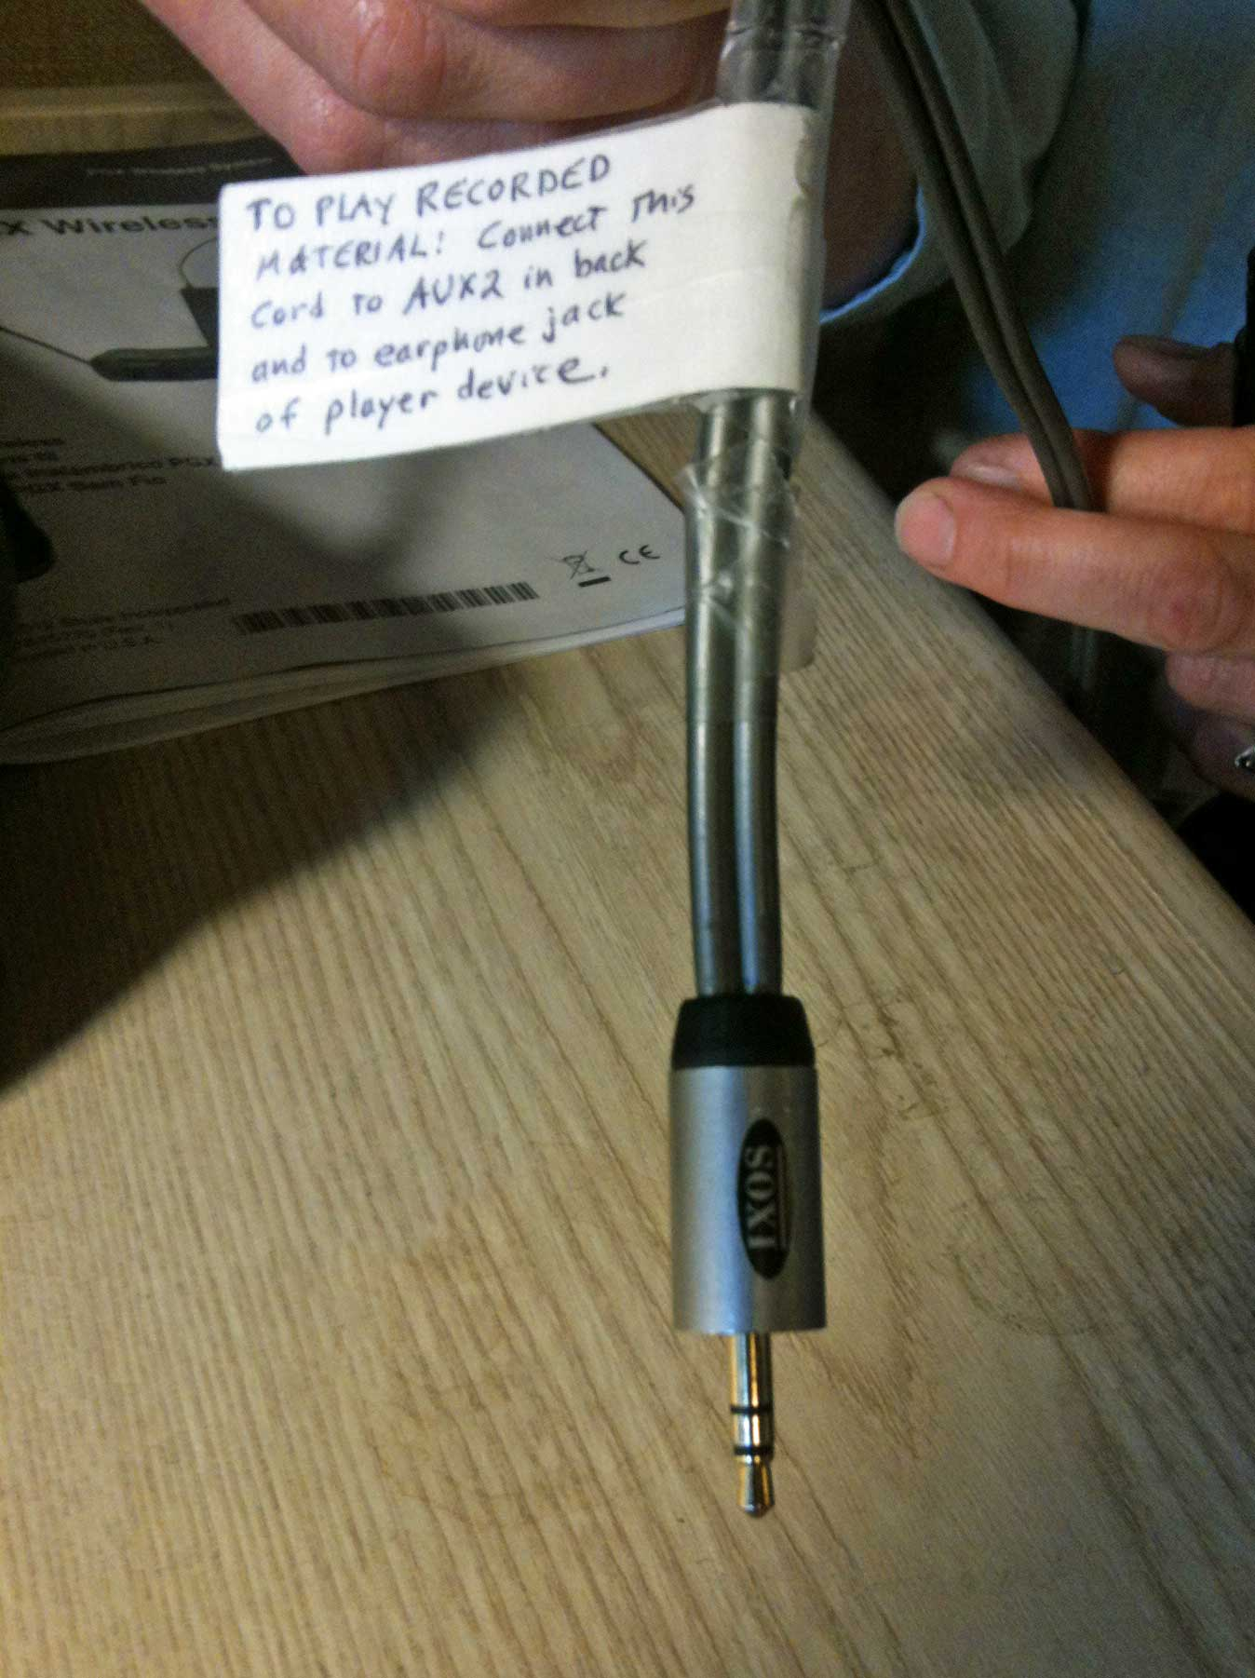
You plug that cable into your device's earphone jack, hit the Play button on your device, and voila. Music comes through the sound system.
It's a REALLY GOOD IDEA to do a sound check before the event to make sure everything is connected correctly and that the volume is set to an appropriate level. The volume is affected both by the volume setting on your playback device and by the AUX 2 knob on the sound system.

